Htek to exhibit at the Channel Partners Conference& Expo
Nanjing, China, March 14, 2018 ,Htek, the global provider of IP handsets to small, mid-sized, enterprise businesses,announced today that it will participate in the upcoming Channel Partners Conference and Expo, which will be held on April 17-20, 2018 at the The Venetian & Sands Expo, Las Vegas, Nevada. 
As a recognized global leading provider of Ip Phones, Htek will be exhibiting a variety of products including its brand-new Wireless &Bluetooth integrated products UC926E ,UC924E,UC912E (coming
soon).
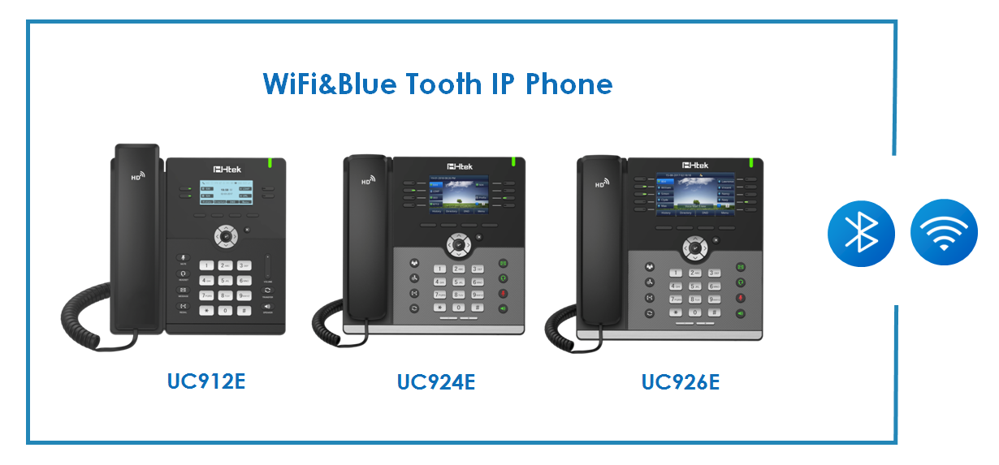
Additionally,the Gigabit Color IP Phone UC926 and UC924, Entry-level IP phone UC912 and the Classic IP Phone UC903 will also be displayed. All of Htek’s UC 900 series VoIP phones are fully certified with Broadsoft, 3CX,Alcatel-Lucent, Metaswitch,Yeastar, FreePBX, Vodia and so on.
“We are pleased to attend this event because it gives us a chance to interact more with the Channel partners.We will take the opportunity to talk to partners about our ever-expanding product portfolio and rapidly expanding company development footprint. We continue to provide best-in-class Ip phones to business of all sizes, and thus,we create greater opportunities for the channel partners.”Said Nico Tao, VP of sales at Htek.
Register today for the special offer .To learn more about Htek Ip products, or discuss partnership opportunities, visit www.htek.com. For the latest news, updates and information ,follow us on Linkedin,Facebook and Twitter.
About Htek
Htek is a world-class designer and manufacturer of enterprise IP phones and gateways. Since 2005, Htek has provided customers in over 80 countries worldwide with high-quality VoIP products. Htek's UC900 IP phones continue the tradition by focusing on cutting-edge features, broad SIP compatibility, and great value. Htek distributes its products via channel partners, and custom designs and rebrands OEM IP phones for large partners such as ITSPs. Htek is a private company headquartered in Nanjing, China, with offices in the US and Europe.
Htek Contact:
Tina Tan
Sales Manager
Hanlong Technology (Htek)
Mobile: +86-138 0158 0192
Email:Tina@htek.com

